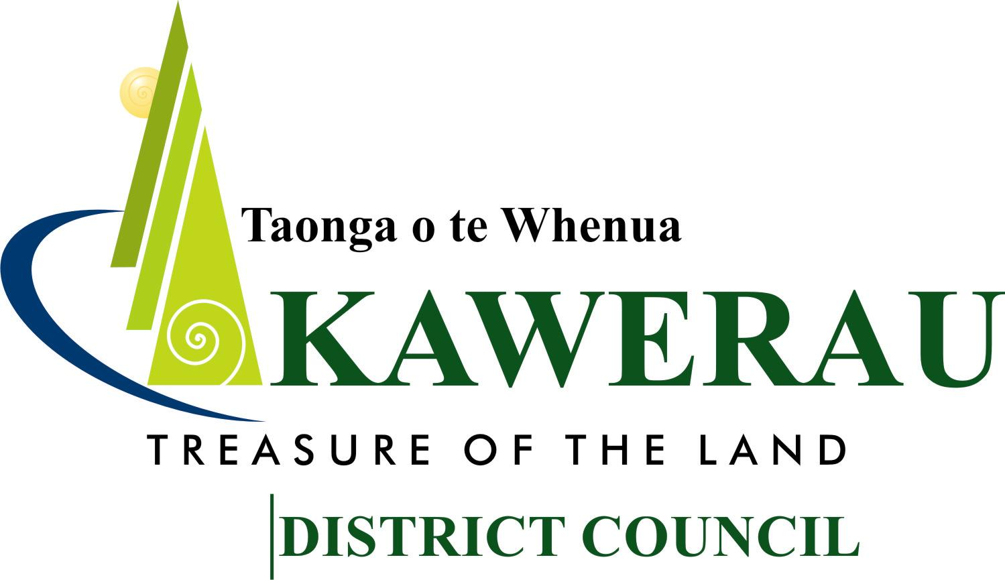

### The Extraordinary Meeting of the

### Kawerau District Council will be

### held on Tuesday, 13 July 2021

### in the Council Chamber

**commencing at 9.00am**

#### A G E N D A

**GUIDELINES FOR PUBLIC FORUM AT MEETINGS**

##### A period of thirty minutes is set aside for a public forum at the start of each Ordinary Council or Standing Committee meeting, which is open to the public. This period may be extended on by a vote by members.

1. Speakers may address meetings on any subject. However, issues raised must not include those subject to legal consideration, or be issues, which are confidential, personal, or the subject of a formal hearing.
2. Each speaker during the public forum is permitted to speak for a maximum of three minutes. However, the Chairperson has the discretion to extend the speaking time.
3. Standing Orders are suspended for the duration of the public forum.
4. Council and Committees, at the conclusion of the public forum, may decide to take appropriate action on any of the issues raised.
5. With the permission of the Chairperson, members may ask questions of speakers during the period reserved for public forum. Questions by members are to be confined to obtaining information or clarification on matters raised by the speaker.

**The Extraordinary Meeting of the Kawerau District Council**

**will be held on Tuesday, 13 July 2021 in the**

**Council Chamber**

**commencing at 9.00am**

A G E N D A

**Apologies**

**Declarations of Conflict of Interest**

Any member having a “conflict of interest” with an item on the Agenda should declare it, and when that item is being considered abstain from any discussion or voting. The member may wish to remove themselves from the meeting while the item is being considered.

**1 2021 Representation Arrangements Review (Electoral Officer – Dale Ofsoske) (101200)**

Pgs. 1 - 8

Attached is a report from Councils Electoral Officer requesting Council determine the representation arrangements for the 2022 Council Elections.

**Recommendations**

1. *The Kawerau District Council resolves as it initial proposal for the 2021 representation arrangements review that:*

*(i) Councillors be elected by electors of the District as a whole (comprising the area in*

*SO Plan 57977) and that the District not be divided into wards*

*(being status quo);*

*(ii) the number of Councillors to be elected be 8 (eight), plus the Mayor*

*(being status quo);*

*(iii) there be no communities or community boards*

*(being status quo)*

*Noting that the above arrangements still:*

* *Best reflect the Districts shared community interest;*
* *Provide greater diversity of views around the Council table;*
* *Provide effective representation (including taking into consideration Councillor workload, access to community organisations and constituents).*

*2. That the formal legislative consultative process and timetable contained in this report*

*be adopted.*

*3. That the hearing of any representation arrangements review submissions that may be*

*received be heard by Council in early August 2021.*

R B George

**Chief Executive Officer**

Z:\2021\03\Meetings\Extraoridnary\Extraordinary Agenda\13.07.21 Council Extraordinary Agenda.docx